Data Structures (ETCCDS202)
Unit–4 Assignment: Non-Linear & Advanced Data Structures
Course Details
Name of the School: School of Engineering & Technology
Program (Class / Semester / Batch): B.Tech (CSE /Robotics and AI) Sem-A
Course Title: Data Structures
Course Code: ETCCDS202
Unit Number: 4
Unit Title: Sorting Algorithms
Student Name: Ajitesh Singh Gusain
Roll No. :2501630014
Submitted to: Dr . Aarti Sangwan

Task 1: Binary Search Tree (BST) Operations Goal: Build an ordered structure that supports efficient search and sorted traversal.

1. Binary Search Tree (BST) Operations
- Sorted In order Traversal: In a Binary Search Tree, the left subtree contains only nodes with keys lesser than the root, and the right subtree contains only nodes with keys greater than the root. By following the In order pattern (Left > Root > Right), we naturally visit these elements in their strictly increasing numerical order.
- Time Complexity Analysis:
  - Average Case O(\log n): In a balanced tree, each comparison allows us to discard approximately half of the remaining search space, leading to logarithmic time performance.
  - Worst Case O(n): This occurs if the tree becomes "skewed" (resembling a linked list), requiring the algorithm to traverse every single node.

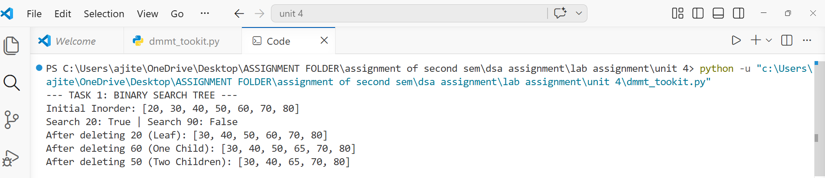
Task 2: Graph Representation + BFS and DFS
BFS vs. DFS: Breadth-First Search (BFS) explores the graph level-by-level, visiting all immediate neighbours before moving to the next depth. In contrast, Depth-First Search (DFS) explores as far as possible along a single branch before backtracking to explore other paths.
Real-World Applications:
- BFS: Widely used for finding the shortest path in unweighted networks, such as GPS navigation systems.
- DFS: Frequently utilized for cycle detection in circuits or topological sorting for complex task scheduling.
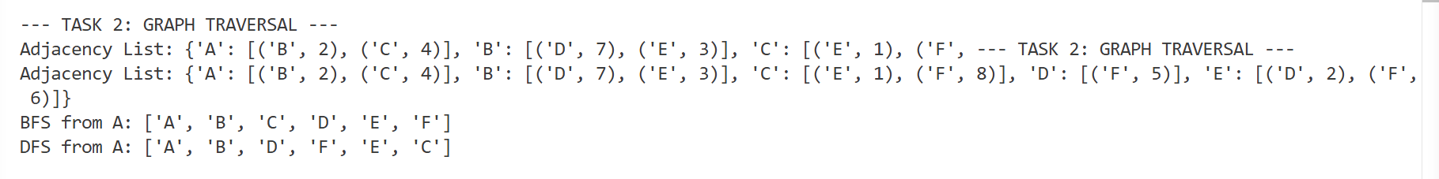
Task 3: Hash Table with Separate Chaining (Collision Handling)
BFS vs. DFS: Breadth-First Search (BFS) explores the graph level-by-level, visiting all immediate neighbours before moving to the next depth. In contrast, Depth-First Search (DFS) explores as far as possible along a single branch before backtracking to explore other paths.
Real-World Applications:
- BFS: Widely used for finding the shortest path in unweighted networks, such as GPS navigation systems.
- DFS: Frequently utilized for cycle detection in circuits or topological sorting for complex task scheduling.

Dmmt_toolkit.py
